**Search Engine Optimisation (SEO)** -It is a technical, analytical and creative process to improve the visibility of a website in search engines.

Imagine that you are a librarian and your library offers each and every book available In the world.

People depends on you everyday whatever book they need. Then How will u do it???

You obviously need a system.you should know what content each book contain and how are the books relates to each other. Similar books should be kept together.All this info should be stored by your system.And provide necessary details when needed. Its not an easy job rytt.

Similarly search engines like google, bing, yahoo are like librarians of the internet. Their systems collect all the info of pages available on web so that they can help people finding exact information what they are actually searching for.

Every search engine has a secret recipe called an algorithen for turning all the important information on web into useful search results.

Now if you own a website, search results matter.When your page have higher ranking then more people will find you and reach your website.

The key for higher ranking is making sure that your website has the necessary ingredients that search engine needs for their recipe. So this whole process is known as search engine optimization or SEO. A good % of entry into internet begins with a search engines only.

Now lets discuss what are those ingredients

* Word matter- Search engine account for every word on internet.If someone searches for Best Online Shoes then search engine will focus on that words “ Best Online Shoes” and match with the websites containing these words and show those sites on top results.
* Title Matter- Search engine mainly looks for the title. Like a book has a specific title which represent and specify what the book is all about. Similarly a post on a website must ensure that it contains the title of the post inside the title tag just like this

**<Title>Best Online Shoes Available here</title>**

* Links- More the number of links of other websites on your page. google will consider your website higher in ranking than others.This factor plays biggest role in SEO.lots of links coming to your website is highly considered by search engine. But many of the times log bevkuff bnaane lg jaate hai search engine ko by linking unnecessary sites to their own sites. Higher ranking tbhi hogi agr link building good links ki hai means achi achi trustworthy sites ke links agr aapki site pe hai then google will rank ur site higher.
* Words in links- it means that when a word links to another site. For example in your site it is written Amazon has a lot of BOOkS( books is mentioned as a link to amazon site).Then if anyone searches for Books then chances of appearing your site on top rank by google is possible
* Reputation-It is basically quality and quantity of content a site has .google will rank those website those are reputed. Here Reputation means good content, Max number of links, and frequently updation of website matters allot

Once your website gets higher ranking in search results on first page then it is very rare that the website will loose its reputation in front of search engine or it goes down in search results.

Ques – How Search engine Works?

It focuses on these three features-

1. Crawling
2. Indexing
3. Rank and serve

Lets discuss these one by one

1. **Crawling a page-**

Every Search engine has a crawler or Bots that visits on every page available on the web and results it back on its servers and stores that page on its servers. So basically google is creating a copy of each and every page on the web on its servers.

So it is performing 4 steps

* Go out
* Crawl the page
* Bring it back to the server
* Save page to the server

Then it crawls those pages more that are very frequently updated and refreshed.

A time was there when google was born .At that tym google takes 3 months to complete one rounf of crawling. But today google crawls every website on the web hourly. It crawls those sites first whose pages are frequently updated.

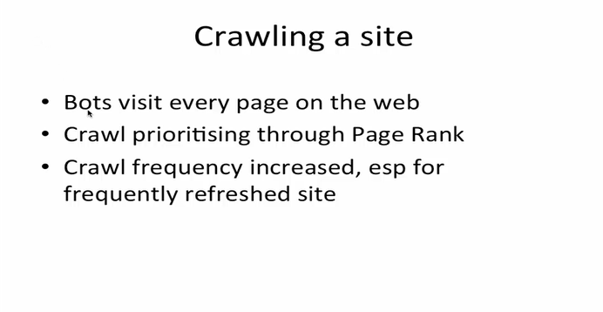

Now for crawling, google prioritise every website by using page rank. They basically look at the value of page like pages of times of india, NDTV, Amazon and many more that are highly information driver pages and changes very frequently as we can say on hourly basis. But pages of co-operate website like IBM etc which are not frequently updated are crawled once or twice in a day.

Next like if someone is having a blog website.And the blogger is updating the blog and writing new content then might be crawler crawls that page again on weekly basis. So everything depends on the priority that crawler decides.

Google has a webmaster tool which helps the website owner to check how many times the crawler is crawling its website .The owner can check the report by using tools that the google provides.

So it is better that we update the content of website frequently so that google can consider our high frequency and shows our website on top ranking

1. **Indexing the site-**

Now after crawling .google has a way of indexing a website by arranging the sites in certain order.Google has multiple indexes like it seprates the index by the topic for example there can be an index for News sites, for sports sites, for corporate websites, for blogging sites and many more .Multiple indexes forms the main index. Google by looking on indexes prioritise which sites should be crawled first. Next within the particular index type google arranges the website by the word order like some pages contain only word “Amitabh” those will be arranged together then some will contain bachhan those will be together and some will contain Amitabh bachhan then those pages will be arranged together. So this Is what google does after crawling that is creating different indexes for similar websites and second is arranding the pages according to the word order.

1. **Rank and serve-**

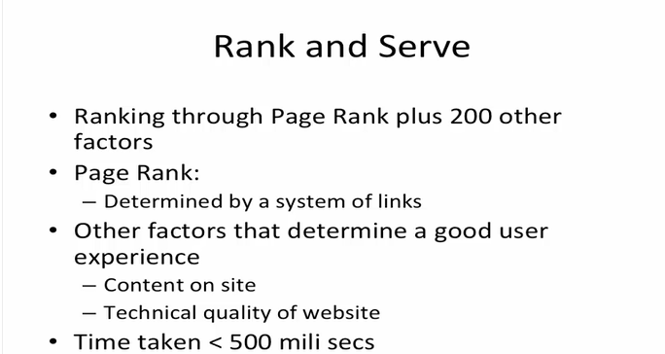

Now for a particular keyword research there can be more than 200 results listed by google. Now how to rank it .how to decide the ranking in search results.This is what we are going to discuss now.

For this google uses its algorithem which contains around 200 factors.All the 200 factors are summed up together to calculate a term known as **page rank .**And according to this page rank all the websites are ranked and being served.

The page rank is mainly determined by a system of links. We had discussed this earlier too that the system of links is the main ingredient of search engine recipe. So the more people are talking about your website on their websites the more number of links you will accumulate and the more links you will get ,the better ranking of your website will be done.But this is only 1 factor among 200 factors. Some other important factors are how fast your site loads, quality of content your site provides then only the user will come to your site again and again if you will provide quality content, others factors like bounce rate, page speed, site is mobile friendly or not or we can say responsive or not and many more that we will discuss later on.